Javascript

**async** vs. **defer**

**Module**, **Import**, **Export**

Modules are *deferred* by default

Object:

* here creating object directly without class template

objects are typically constants, we can change the properties of the object inside the container, but can’t remove or replace the object from the container

e.g. call constant name, use = symbol to set the contents to something else, won’t compile. I.e. you can change its properties, but can’t change it something completely different

Classes / Class:

Q: can an object created from a class have the same name as the class?

A: No, if the class is a constant, this will cause an error. If the class is not a constant, the new object will overwrite the class.

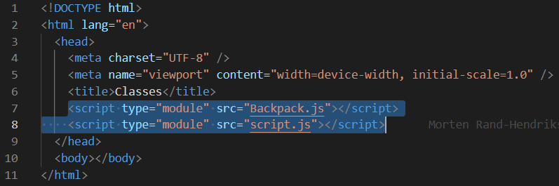

Object construction function:

This is the old way of doing things, not advised b/c can’t be extended like a class.

**Template literal**, injecting Javascript into HTML, note, use back tick

Traditional string output, output a mix of HTML and Javascript expressions

Old way of doing things, now use Template literal

**querySelector**, **querySelectorAll** (in browser console)

Element.**classList**, **classList**

<https://developer.mozilla.org/en-US/docs/Web/API/Element/classList>

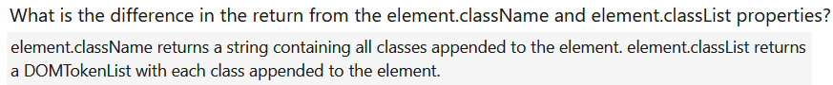

Element.**attributes**, **attributes**

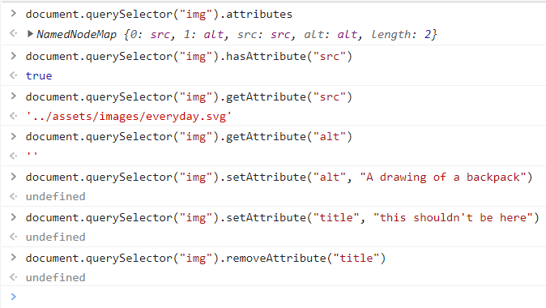

**Inline** CSS **style**

**Append** Template Literal to Main, add DOM elements, **main.append()**, **ParentNode.append()**

if want to add to the beginning, ParentNode.**prepend()**

Other methods: Node.**appendChild**(), Node.**replaceChild**(), Node.**insertBefore**(), Node.**insertAdjacentElement**()

another example

Function Expression:

Do not use function expression, b/c of scoping issues. Use arrow function. <https://developer.mozilla.org/en-US/docs/Web/JavaScript/Reference/Functions>

Arrow function cannot be used to define an object method, hence in example – newVolume: function (volume) {};

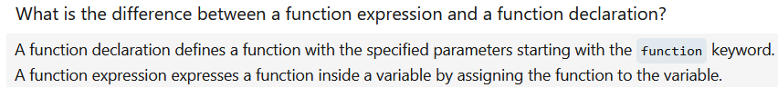

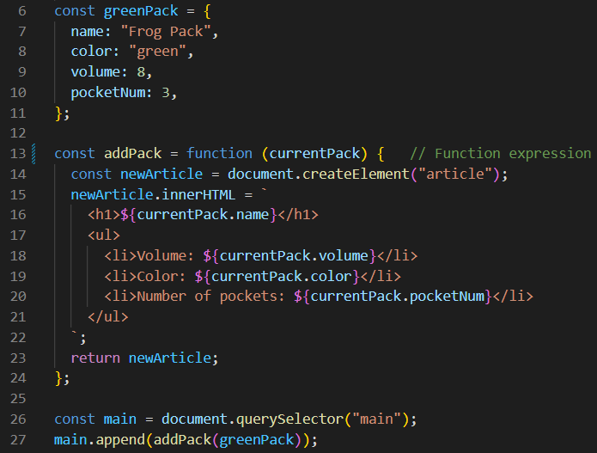

Arrow function:

<https://developer.mozilla.org/en-US/docs/Web/JavaScript/Reference/Functions/Arrow_functions>

**for loop:**

for … of: loop through data structure (e.g. array)

for … in: loop through nested object

forEach loop

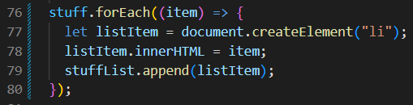

Array map(), map

Eventlistener, eventlistener

